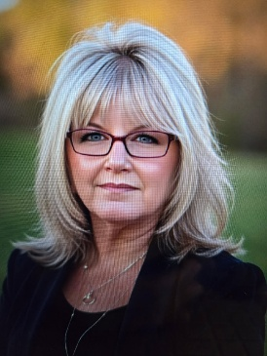
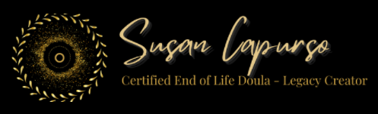

Susan Capurso BIO and Information

Susan Capurso is a renowned Legacy Specialist, End of Life Doula and Funeral Celebrant, dedicated to helping individuals preserve their life stories, wisdom, and memories for future generations. With a passion for creative legacy work, Susan serves clients worldwide, guiding both end-of-life individuals and healthy adults in crafting meaningful legacies that transcend time.

As the founder of East End Doula Care LLC in Suffolk County, New York, Susan brings a wealth of experience to her role. She is a four-time author, and offers a holistic approach to legacy preservation and end-of-life care. Her collaboration with Attorneys providing Legacy Will Services, underscores the importance of integrating personal legacies with legal planning.

She serves as an Adjunct Professor for Stony Brook University, teaching workshops on the three stages of end-of-life and Creative Legacy. Her educational reach includes training National Organizations about End-of-Life care, providing CE Credits for Social Workers and Case Managers. This commitment to education is further exemplified through her weekly YouTube Channel, "End of Life Journey and Beyond: The Sands of Time," where she offers invaluable insights into navigating the end-of-life journey, before, during and after.

Deeply involved in her community, Susan serves on multiple boards and committees, including the Patient and Family Advocacy Council and the In-Patient Experience Committee for Stony Brook University Hospital, the board of Pulse – Patient Safety, Education and Advocacy, and the National Aging in Place Council for both Nassau and Suffolk County chapters. Her volunteer work with East End Hospice in Westhampton, NY demonstrates her commitment to supporting individuals through all stages of life and loss.

Susan's impact has been recognized nationally, with features in Newsday, the New York Post, and numerous blogs, radio shows, podcasts, and local television stations. She is the author of "Coming Full Circle," "Remember Me – the Story of My Life," , "Before You Go," and her latest, “The Routledge Handbook of Contemporary Ageing Issues – Global and Country Narratives. Each work contributing to her mission of helping others preserve their legacies and to do end of life right..

Inspired by personal experience, having lost 14 close family members, Susan has channeled her grief into a powerful mission. She aims to ensure that everyone experiences a beautiful end-of-life journey and achieves the closure they deserve. Susan multifaceted approach to legacy work has established her as a leading voice in helping individuals leave lasting, meaningful legacies for generations to come.

Susan Capurso - For more information please contact: 631-946-8100
Email: Susan@EastEndDoulaCare.com
Website: www.SusanCapurso.com
Member of: INELDA – International End of Life Doula Association / NEDA – National End of Life Doula Alliance, National Aging in Place Council, PULSE, Stonybrook University Hospital.

