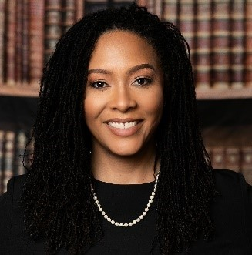

Hon. Cassandra A. Johnson is the Surrogate of Queens County and previously served as a Justice of the Queens Supreme Court and Judge of the Civil Court of the City of New York. Judge Johnson has served as a principal law secretary and court attorney referee in the Queens Supreme Court, Civil Term, specializing in foreclosure, matrimonial and commercial matters. As part of the statewide initiative to implement Presumptive Alternative Dispute Resolution, Judge Johnson was a trained mediator of civil and commercial disputes. Judge Johnson is a faculty member at the NYS Judicial Institute and member of the Statewide Surrogate’s Court Working Group.
Prior to her service in the court system, Judge Johnson worked as an attorney for the City of New York, where she focused her practice on preventative law and civil litigation. She began her legal career in private practice as an estate litigation and real estate associate at the Law Offices of Andrée Sylvestre. Judge Johnson was a contributing writer and editor of the chapter entitled “Commercial Leasing,” which was published in the fourth edition of West's New York Practice Series, Commercial Litigation in New York State Courts.
Judge Johnson obtained her juris doctor and bachelor’s degree in mathematics from St. John’s University. She is admitted to practice in New York and Connecticut, as well as the United States District Court for the Eastern and Southern Districts of New York. Judge Johnson is a board member of the Queens County Women’s Bar Association and Catholic Lawyers Guild of Queens, mentor with the Franklin H. Williams Commission, and cochairs the Collaborative Law Committee of the Women’s Bar Association of the State of New York.

